**DBMSLab-Assignment 2**

Q1: Create a new user making “your_name” as user-name and “your_surname” as the password.

🡺create user bibek identified by root;

Q2: Grant all privileges to the newly created user.

🡺 grant all privileges to bibek;

Q3: connect to the new user.

🡺connect

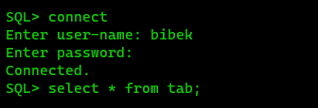

Q4: Create a table employee with attributes emp_id, f_name , l_name , job_type, salary, commision, dept, and manager_id.

🡺 CREATE TABLE Employee (

employee_id INT,

first_name VARCHAR(10),

last_name VARCHAR(10),

job_types varchar(10),

salary number,

commission number,

dept VARCHAR(10),

manager_id number);

Q5: Describe the table employee

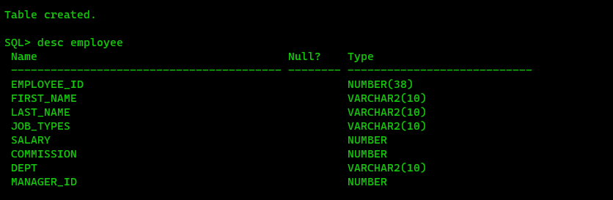🡺 DESC employee

Q6: Add a new column doj to the employee table.

🡺alter table employee add doj date;

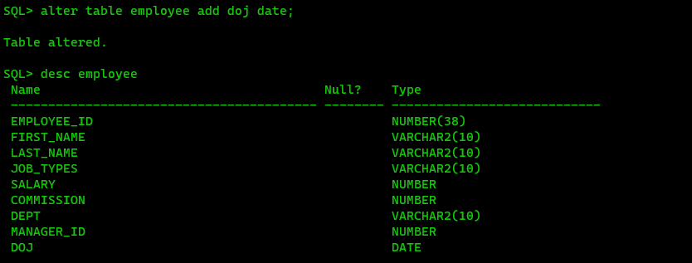

Q7: Create a new table department with attributes d_name, d_loc, and hod_id.

🡺 CREATE TABLE department ( d_name VARCHAR(10), d_loc VARCHAR(10), hod_id number);

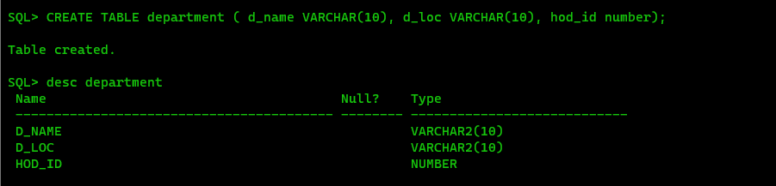

Q8: Create another table named location with attributes loc_id, city and contact_no.

🡺 CREATE TABLE location ( loc_id number, city VARCHAR(10), contact number);

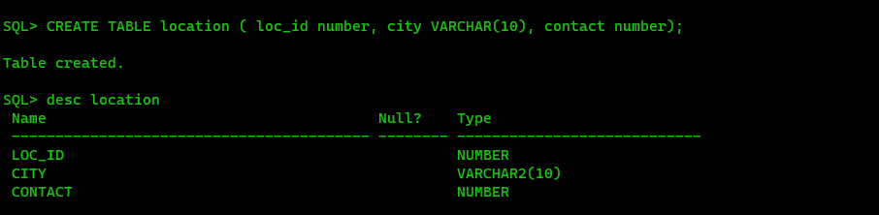

Q9. Enhance the size of city attribute in location table by 5.

🡺 ALTER TABLE location MODIFY city VARCHAR(5);

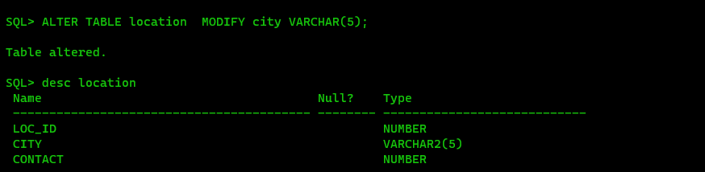

Q10. Delete the contact_no attribute in the location table.

🡺 ALTER TABLE location SET UNUSED COLUMN contact;

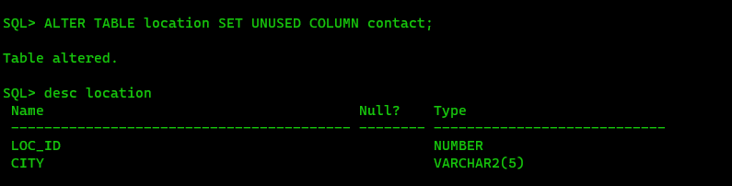

Q11. Rename the city attribute in the location table to address.

🡺 ALTER TABLE location RENAME COLUMN city TO address;

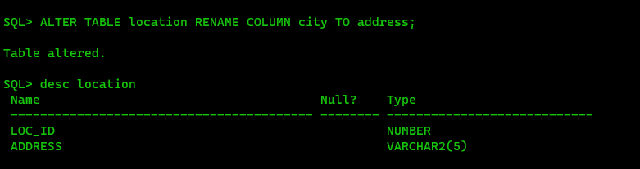

Q12. Change the name of the table from location to loc.

🡺 RENAME location To loc;

Q13. Insert the following values into the loc table.

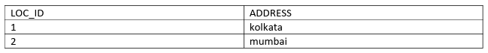

🡺 insert into loc values (01, 'Kol');

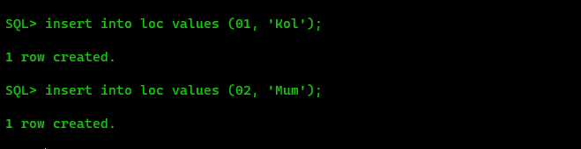

Q14. Show the values of location table.

🡺 select * from loc;

Q15. Delete all values and spaces consumed by loc table.

🡺 TRUNCATE TABLE loc;

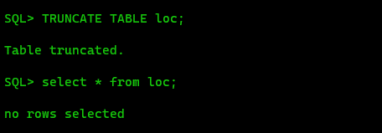

Q16. Delete the loc table.

🡺 drop table loc;

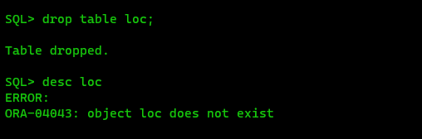

Q17. Insert the following values into the department table.

🡺 insert into department values ('&d_name', '&d_loc', &hod_id);

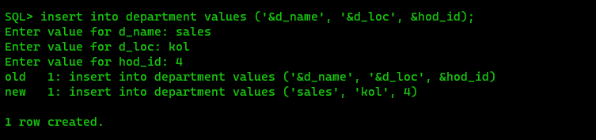

Q18. Insert the following values into the employee table.

🡺 insert into employee values (&employee_id, '&first_name', '&last_name', '&job_type', &salary, &commission, '&dept', &manager_id, '&doj');

Q19. Save the database.

🡺commit;



Q20: Show all the attribute values of the department table.

🡺 select * from department;

Q21: Display the department names and their locations.

🡺 select d_name, d_loc from department;

Q22: Show the employee’s first name, last name, current salary and the salary with a 1000 rupees bonus.

🡺 SELECT first_name, last_name, salary, salary + 1000 AS Salary_With_Bonus FROM employee;

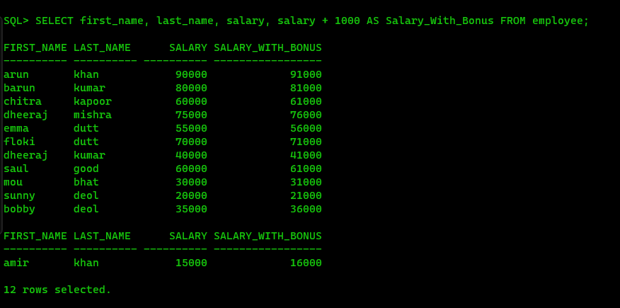

Q23: Show the employee’s annual salary with a 1000 rupees yearly bonus and the annual salary with a 100 rupees monthly bonus.

🡺 SELECT first_name, last_name, salary * 12 + 1000 AS Yearly_Bonus, (salary + 100) * 12 AS Monthly_Bonus FROM employee;

Q24: Show f_name as Name and annual salary as ANNSAL from the employee table.

🡺 SELECT first_name AS Name, salary * 12 AS ANNSAL FROM employee;

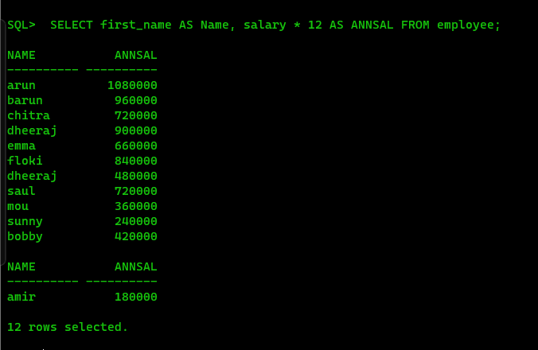

Q25: Show the L_name as SurName and 100 rupees incremented salary as NewSal from the employee table.

🡺 SELECT last_name AS SurName, salary + 100 AS NewSal FROM employee;

Q26: Display the employees f_name and l_name joined together using the concatenation operator.

🡺 SELECT first_name || ' ' || last_name AS Full_Name FROM employee;

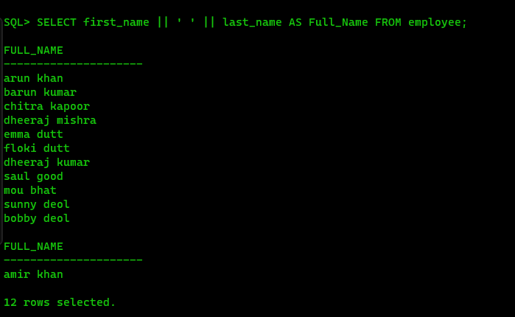

Q27: Show the f_name, l_name and job_type as Employees.

🡺 SELECT first_name, last_name, job_types AS Employees FROM employee;

Q28: Show the employee details in the following fassion:

Employees Details

--------------------------------------------------------

arun khan is a manager

barun kumar is a manager

……..

……..

🡺 SELECT first_name || ' ' || last_name || ' is a ' || job_types AS Employees_Details FROM employee;

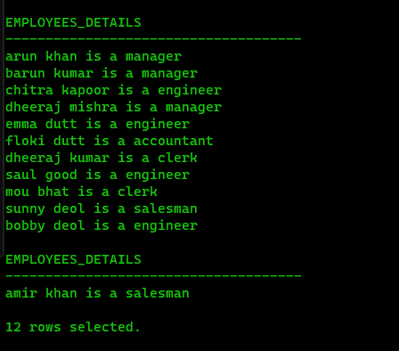

Q29: Show the monthly salary details in the following fassion:

Monthly Salary Details

--------------------------------------------------------------------------------

arun's monthly salary is 90000

………

🡺 SELECT first_name || '''s monthly salary is ' || TO_CHAR(salary) AS Monthly_Salary_Detalil FROM employee;

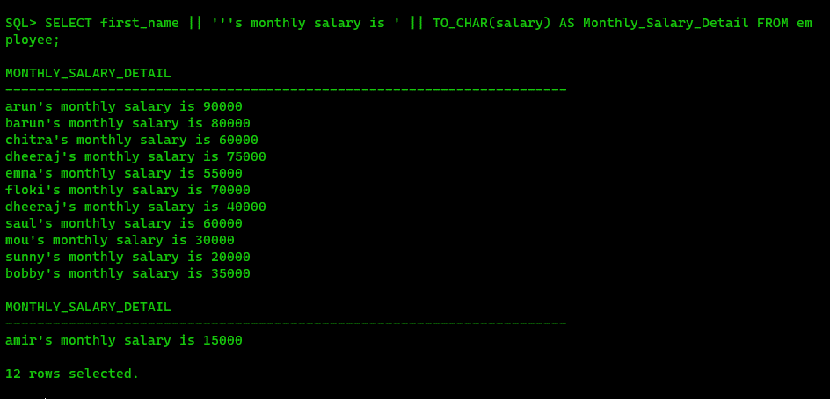

Q30: Show the department names from the employee table.

🡺 select dept from employee;

Q31: Show the distinct department names from the employee table.

🡺 SELECT DISTINCT dept FROM employee;

Q32: Show the employees earning more than 50000.

🡺 SELECT * FROM employee WHERE salary > 50000;

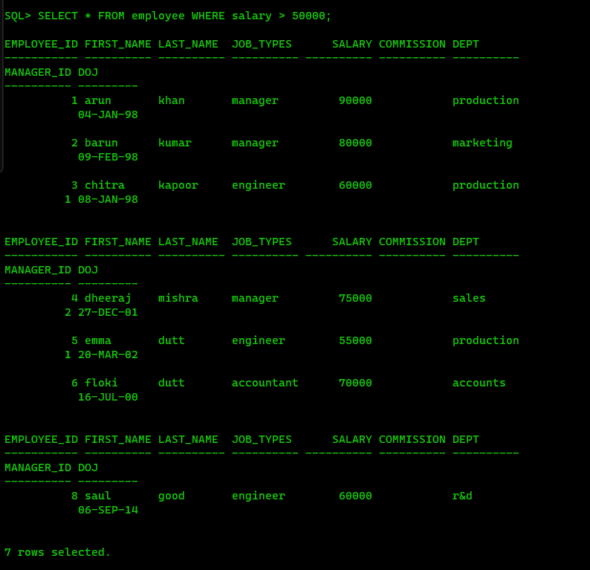

Q33. Show the employee’s id’s who are not working under manager id-1.

🡺 SELECT employee_id FROM employee WHERE manager_id != 1;

Q34: Show the employee’s names and salaries whose salary ranges between 40000 to 70000.

🡺 SELECT first_name, last_name, salary FROM employee WHERE salary BETWEEN 40000 AND 70000;

Q35: Show the employees who work for manager id 1 or 6 or 8.

🡺 SELECT * FROM employee WHERE manager_id IN (1, 6, 8);

Q36: Select the first names and salaries of those employee whose last name is khan.

🡺 SELECT first_name, salary FROM employee WHERE last_name = 'khan';

Q37: Select the first names and salaries of those employee whose last name starts with k.

🡺 SELECT first_name, salary FROM employee WHERE last_name LIKE 'k%';

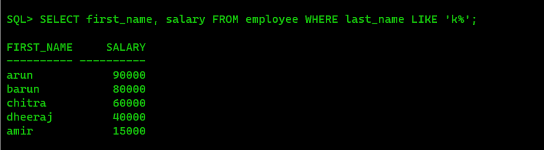

Q38: Select the first name, last name and salary of those employee whose last name starts with k and ends with r.

🡺 SELECT first_name, last_name, salary FROM employee WHERE last_name LIKE 'k%r';

Q39: Select the employees whose 3rd letter of their last name is o.

🡺 SELECT * FROM employee WHERE SUBSTR(last_name, 3, 1) = 'o';

Q40: Select the employees who are not working under any manager.

🡺 SELECT * FROM employee WHERE manager_id IS NULL;

Q41: Select the employees who work as engineers with salary greater than 50000.

🡺 SELECT * FROM employee WHERE job_types = 'engineer' AND salary > 50000;

Q42: Select the employees who work in the production department or earns more than 60000.

🡺 SELECT * FROM employee WHERE dept = 'production' OR salary > 60000;

Q43: Select those employees who are not managers or engineers or clerks.

🡺 SELECT * FROM employee WHERE job_types NOT IN ('manager', 'engineer', 'clerk');

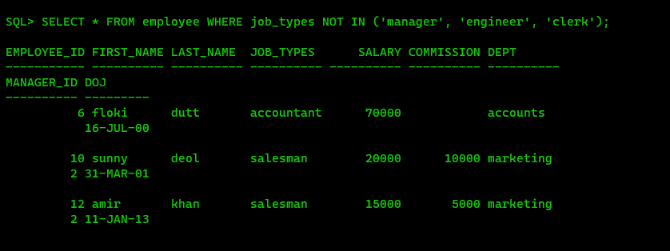

Q44: Select the employees who earns more than 49000 or less than 29000.

🡺 SELECT * FROM employee WHERE salary > 49000 OR salary < 29000;

Q45. Select the employees who don’t have an ‘o’ as the 2nd last letter of their last name.

🡺 SELECT * FROM employee WHERE SUBSTR(last_name, -2, 1) != 'o';

Q46. Select the employees who get commission.

🡺 SELECT * FROM employee WHERE commission IS NOT NULL;

Q47. WAQ to display the current date.

🡺 SELECT SYSDATE AS current_date FROM dual;

Q48. Show the total experience in weeks for all the employees.

🡺 SELECT employee_id, first_name, last_name, doj, TRUNC((SYSDATE - doj) / 7) AS experience_in_weeks FROM employee;

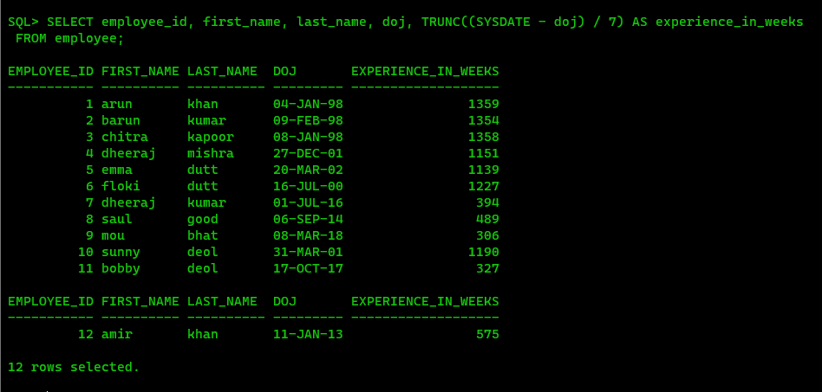

Q49. Find the employees working under employee_id 2.

🡺 SELECT * FROM employee WHERE employee_id = 2;

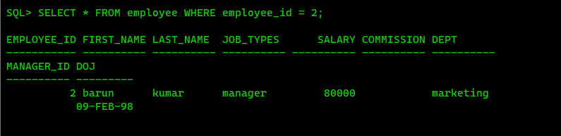

Q50. Delete the employees from sales department if they are not working as managers.

🡺 DELETE FROM employee WHERE dept = 'sales' AND job_types != 'manager';

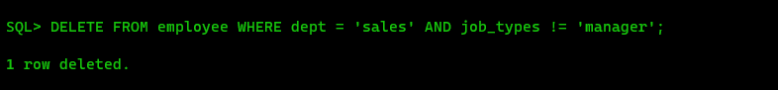

Q51. Insert the following two rows in the employee table without inserting any value in the department field.

🡺 insert into employee values (&employee_id, '&first_name', '&last_name', '&job_type', &salary, &commission, '&dept', &manager_id, '&doj');

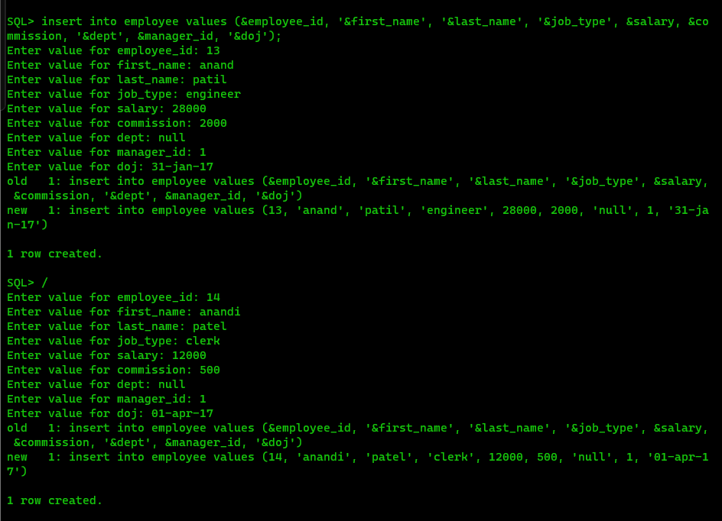

Q52. . Insert the following two rows in the department table.

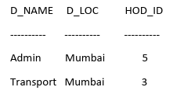

🡺 insert into department values ('&d_name', '&d_loc', &hod_id);

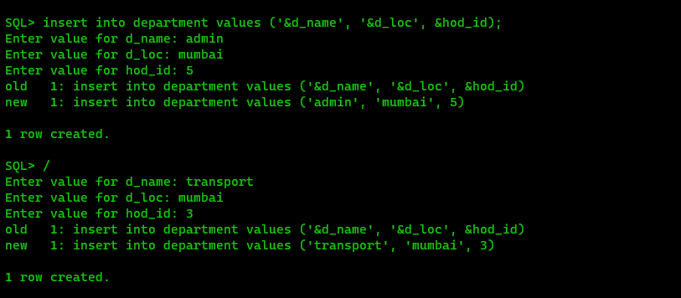

Q53. Update the employee table. Assign Anand to the admin department.

🡺 UPDATE employee SET dept = 'admin' WHERE first_name = 'anand';

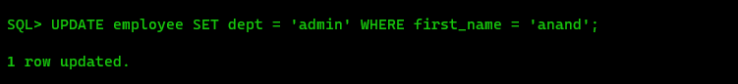

Q54. Update the manager_id from 2 to 1 in the employee table.

🡺 UPDATE employee SET manager_id = 1 WHERE manager_id = 2;

Q55. Display the employee details in descending order on their salary.

🡺 SELECT * FROM employee ORDER BY salary DESC;

Q56. Display the employee details in ascending order on their l_name.

🡺 SELECT * FROM employee ORDER BY last_name ASC;

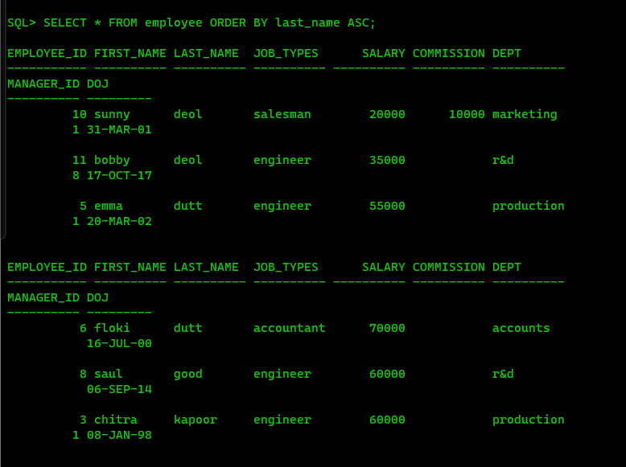

Q57. Delete the employees who are working as salesmen and having less experience than 15 years.

🡺 DELETE FROM employee WHERE job_types = 'salesman' AND (SYSDATE - doj) / 365 < 15;

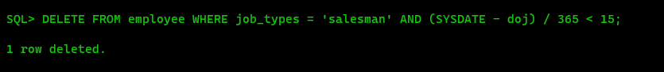

Q58. Commit the database.

🡺commit;

